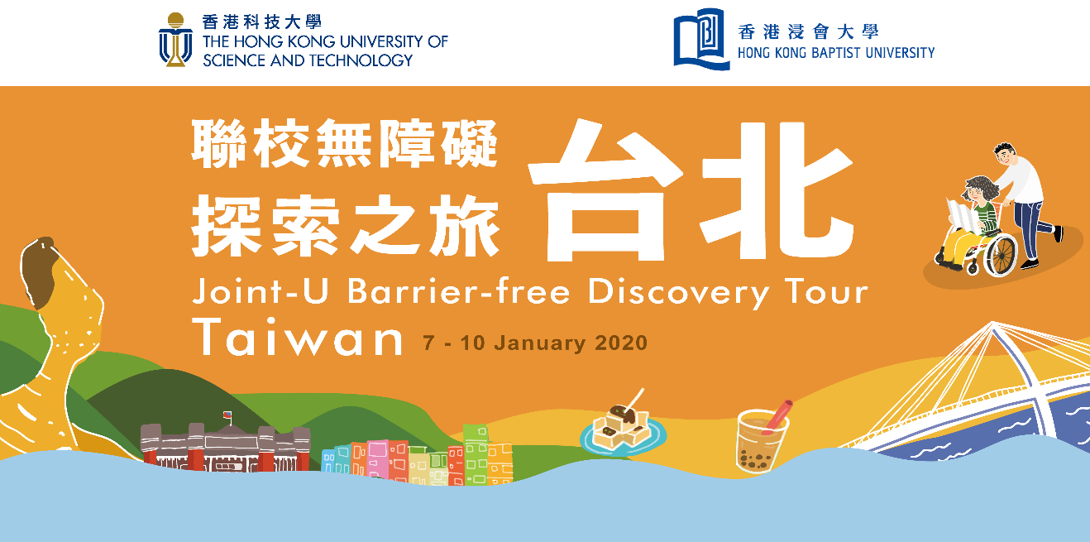

Schedule and Activities

- Tentative schedule of the Initiative

Date | Activity & Task
5:30 p.m., 31 Oct 2019 (Thu) | Application deadline
11 Nov 2019 (Mon) | Selection Interview:  AM: HKUST  PM: HKBU
20 Nov 2019 (Wed) | Result of application release
By 29 Nov 2019 | Offer Acceptance  - Settlement of tour deposit  - Submission of required items as listed in the Part A of “Undertaking”
23 Dec 2019 (Mon) | Training & briefing session on the Tour and the Project Work
7 – 10 Jan 2020 | Tour in Taipei
By early February 2020 | Debriefing of the Tour
By 31 March 2020 | Deadline to complete the Project Work
By 4 May 2020 | Refund of deposit to participants successfully completed the Initiative with required documents duly submitted.

- Tentative schedule of the Tour in Taiwan

Date | Activities | Remarks
7 January, 2020  (Tue) | - Flight from Hong Kong to Taipei  - Dark experiential workshop  - Dinner at night market by participants’ own arrangement
8 January, 2020  (Wed) | - Breakfast at Hotel  - Barrier free discovery visit and lunch at countryside of Taipei  - Group hot-pot dinner | Experienced inclusive tour guide in wheelchair
9 January, 2020  (Thu) | - Breakfast at Hotel  - Study Tour, lunch and exchange with the National Taiwan Normal University  - Dinner at night market by participants’ own arrangement | Introduction of Special Education policy, student exchange and visiting barrier free facilities on campus
10 January, 2020  (Fri) | - Breakfast at Hotel  - Taipei handcraft workshop and lunch  - Flight from Taipei to Hong Kong | “我的自拍印章” DIY stamp and postcards at Fab Cafe

