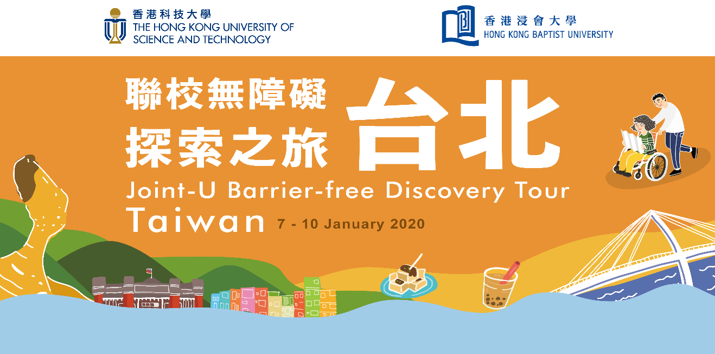

Health Declaration Form

This medical form helps the Organizers to ensure a safe experience for you. We urge you to be completely thorough in providing us with the information requested. Information provided will be handled with strict confidence and with accordance to the University’s data privacy policy and that in Hong Kong.

Personal Information

Full Name (Eng): |  | Full Name (Chi):
Student ID: |  | Date of Birth:

Medical Condition

Have you ever had the following medical condition(s)? Please put a tick “” in the box(es) below:
 | Anaemia 貧血 |  | Hereditary disease 遺傳疾病
 | Asthma 哮喘 |  | Measles 麻疹
 | Cancer 癌症 |  | Mental illness 精神病患
 | Cardiovascular diseases 心血管疾病 |  | Physical disability 肢體傷殘
 | Convulsion 痙攣 |  | Tuberculosis 结核病
 | Diabetes 糖尿病 |  | Viral hepatitis 肝炎
 | Epilepsy 癲癇 |  | Vision impairment 視障
 | Hearing impairment 聽障 |  | Whooping cough / Pertussis 百日咳
 | Haemophilia 血友病 |  | NONE of the above
Others, please specify:

If you have had the any of the above medical condition(s), please provide further details:

- Allergies / Dietary Restrictions

Do you have any allergies or dietary restrictions?
Yes
No

If Yes, please specify:

Hospitalization

Have you ever undergone any surgery or been hospitalized for observation or treatment in the past 3 years?
Yes
No

If Yes, please specify:

Medication

Are you on medication at the moment?
Yes
No

If Yes, please specify:

DECLARATION AND DISCLAIMER
I hereby declare that the above information provided is, to the best of my knowledge, complete and true.

I certify that I am physically fit to participate in this overseas tour, implying that I have no medical or physical conditions that could interfere with my safety or safety of others, or if I do, I have consulted a doctor in advance, and I am willing to assume and bear the consequential costs of any risks that may be created, directly or indirectly, by any such condition.

I agree that my personal data may be used by the Hong Kong University of Science and Technology and the Hong Kong Baptist University, as well as the appointed tour guides and instructors of the overseas tour for administration, organizing the tour and emergencies.

In consideration for being allowed to participate in this Initiative, I agree to hold harmless to the HKUST/ HKBU and its staff members conducting the events from any and all claims, suits, losses, or related causes of action for damages, including, but not limited to, such claims that may result from my illness, injury or death, accidental or otherwise, during, or arising in any way from, the events. The Organizers reserve the right to decline any participant whose health condition is perceived as interfering safety of the individual or the group.

Personal Information Collection Statement

For data collected from or generated by the organizers or applicants during the Tour’s application process, the Organizers pledge to meet the standard of personal data privacy protection, in complying with the requirements of the Personal Data (Privacy) Ordinance. Data collected will be kept confidential, and they may be transferred to departments / administrative offices within the Organizers, the partnering organization(s), the University Grants Committee, medical institutions, if any, for processing, use and emergency. For further details on the University’s Privacy Policy, please visits:
HKBU: https://www.hkbu.edu.hk/tch/about/privacy.jsp
HKUST: http://www.ust.hk/privacy-policy/

Participant's Signature: Date:

