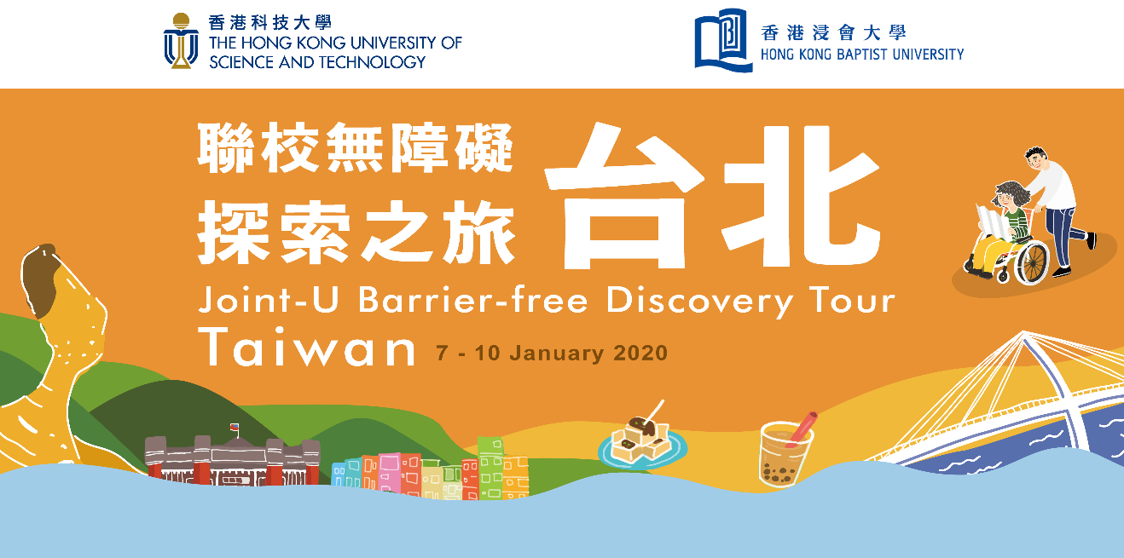

Application Form

Composition of the Initiative
23 December, 2019 | Training & Briefing Session
7 – 10 January, 2020 | Tour in Taipei
By 31 March, 2020 | Project Work to Promote Inclusive Traveling to own Campuses & Social Communities

Notes to Applicants

- All students who wish to participate in the tour are required to complete an application form and go through a selection process. Shortlisted candidates are required to attend an interview and present valid traveling passport in attending the interview.
- As part of the process, successful applicants need to complete and return the Health Declaration Form (Annex 1) to show the suitability in joining the overseas tour. The Organizers reserve the right to decline any participant whose health conditions are perceived as interfering safety of the individual or the group. In that case, the participant should bear the consequential costs of any risks that may be created, directly or indirectly.
- For case of traveling with a care-giver, s/he shall be responsible for his/her own traveling expenses & liability.
- The tour incurs no application fee while a refundable deposit of HK$2,500 will be collected upon confirmation of offer acceptance (by 29 November 2019.) Deposit will be refunded to participants who complete all the components of the Initiative and fulfill the required obligations including the Project Work.
- Participants own the responsibility to obtain valid travel documents to enter/exit Taiwan, if necessary, on own accord and at own expense. Participants are also required to submit photocopy of the “Exit and Entry Permit for the Taiwan Area of the Republic of China” to the Organizers prior to departure (on or before the Training & Briefing session tentatively scheduled for 23 December 2019). If the participant cannot apply the travel documents due to personal reason (e.g. delay, lack of supporting documents), the paid deposit of the Tour will not be refunded. The Organizers also reserve the rights to request for compensation from the participants on any possible loss including travel tickets, accommodation fee, etc. that are already paid.
- Terms and conditions of the travel insurance provided by the University are available on the University websites (HKUST / HKBU). Please purchase separate insurance plan if extra protection is needed.
- Participants must depart from and return to Hong Kong as a team on assigned dates of the Tour and are responsible for all of the own expenses after withdrawal from the team. The Organizers will not certify the completion of Tour to the participants who withdraw from the Tour, which will result in no deposit refund.
- The Organizers reserve the right to adjust the Tour in the overseas trip or even cancel the overseas trip if the Organizers observe that the participants’ personal safety is at high risk due to severe situations (e.g. political instability, natural disasters, pandemic outbreak, etc.) in Hong Kong and the trip destination. The organizer will do the best to make advance announcement if needed.
- The content of the Initiative and the Tour is subject to change without notice. The Organizers accept no liability for any loss or damage howsoever arising from any use or misuse of or reliance on any information in this Initiative/Tour.

Eligibility
- Current full-time HKUST and HKBU students declared with SEN / registered as Peer Counselor (HKUST) / Inclusive Student Ambassador (HKBU) on UGC funded programmes aged over 18 by the time of travel.
- Holder of valid traveling passport allowed to enter Taiwan with validity till 31 July 2020.
- Priority will be given to non-final-year students
- Priority will be given to those with good command of spoken Putonghua.

Coverage of the Tour
- Roundtrip group air-ticket between Hong Kong and Taipei (standard economy class), taxes and surcharges
- Hotel accommodation in Taipei (2 participants in the same gender will share a room)
- Local shuttle bus service in Taiwan
- Breakfast, lunch on all days of the Tour and one group dinner
- Program fees, admission tickets and tour guide service charges
- Student travel insurance of the participants’ own universities (please purchase separate plans if extra protection is needed)

Tentative schedule of the Tour in Taipei
Date | Activities | Remarks
7 January, 2020  (Tue) | - Flight from Hong Kong to Taipei  - Dark experiential workshop  - Dinner at night market by participants’ own arrangement
8 January, 2020  (Wed) | - Breakfast at Hotel  - Barrier free discovery visit and lunch at countryside of Taipei  - Group hot-pot dinner | Experienced inclusive tour guide in wheelchair
9 January, 2020  (Thu) | - Breakfast at Hotel  - Study Tour, lunch and exchange with the National Taiwan Normal University  - Dinner at night market by participants’ own arrangement | Introduction of Special Education policy, student exchange and visiting barrier free facilities on campus
10 January, 2020  (Fri) | - Breakfast at Hotel  - Taipei handcraft workshop and lunch  - Flight from Taipei to Hong Kong | “我的自拍印章” DIY stamp and postcards at Fab Cafe

Submission of Application Forms
Please complete this application form and return to the respective addresses as below by
5:30 p.m. on 31 October, 2019 (Thu):

HKUST: SEN Support, Counseling and Wellness Center
Room 5022, Dean of Students Office, 5/F, lift 3
HKBU: The Unit for Students with Special Educational Needs
Room DLB704A, Level 7, David C. Lam Building, Shaw Campus

OFFICE USE ONLY

Date of Interview |  |  | Application No.
Interviewer |  |  | Approve / Reject
SEN / Peer /Both |  |  | Waiting

Personal Particulars
Full Name (Eng): | (Chi) : ________________________
(as on your valid travel document)
Date of Birth: ___ | Gender: ___________
Student ID No.:____________________________ | Mobile No.:______________________________
Current Programme & Year:_____________________ | Date of Passport Expiry:___________________
University Email: | Type of Passport: ________________________
Languages (Written) ___________________ (Spoken) ______________________________________

Have you ever participated in an overseas study tour / activity / travel? (please tick)
Yes (which year/region?):_________/________________ No ________

Are you a student registered as: (Please tick where appropriate)
SEN: _____________ Peer Counselor/Inclusion Ambassador:__________ Both:________________

Details Special Need on Traveling / Outing (If applicable)

Type of Disability:__________________ ___________________

Medication:___________________________ | Care-giver: Yes: ____________ No:____________
Do you have any special needs on hotel accommodation, meals or flight, etc.? (please tick)
Yes:________ No.: _________
If yes, please provide details:
Extra-Curricular Activity Records in the Recent Two Years

Role | Organization / Name of Event | Period

Personal Statements

- Reason to apply:
Explain why you apply for this Initiative and what do you expect to gain from the experience.

- Self-understanding:
State the challenges you expect to encounter during the overseas Tour and how you would prepare yourself to tackle them. Share if you need any assistive aids / assistance / support from others to participate in the Tour, and whether you are willing to help other teammates throughout the whole project at your own capacity.

- Sensitivity to Inclusion:
The Initiative includes an after-tour project on inclusive traveling for sharing experience with the campuses and general public. Tell us your ideas on presenting your team’s findings / experience to impact the campus and social communities.

Personal Information Collection Statement

For data collected from or generated by the organizers or applicants during the Tour’s application process, the Organizers pledge to meet the standard of personal data privacy protection, in complying with the requirements of the Personal Data (Privacy) Ordinance. Data collected will be kept confidential, and they may be transferred to departments / administrative offices within the Organizers or the partnering organization(s), the University Grants Committee, if any, for processing and use. For further details on the University’s Privacy Policy, please visits:
HKBU: https://www.hkbu.edu.hk/tch/about/privacy.jsp
HKUST: http://www.ust.hk/privacy-policy/

Signature: ________________________________

Name in Block: ____________________________

Date :____________________________________

