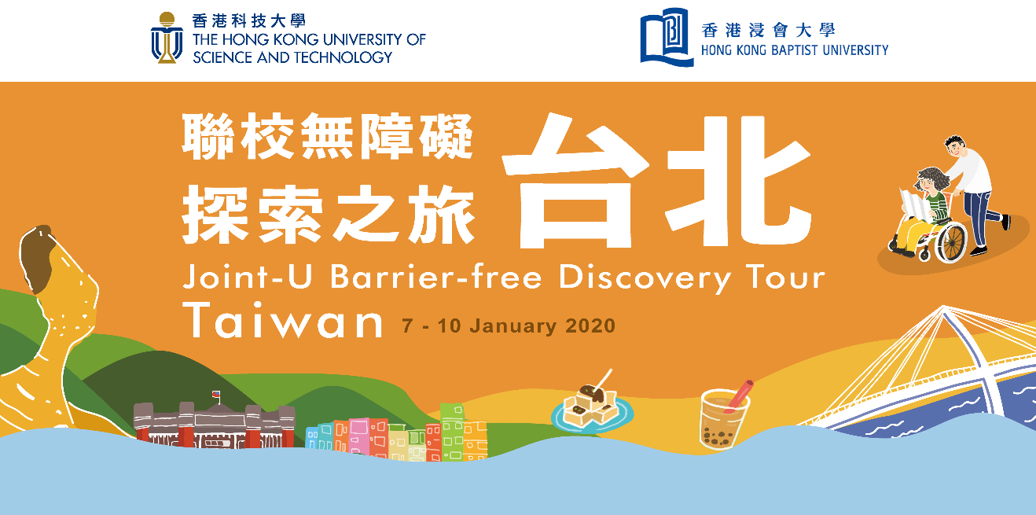

Undertaking

Name of Participant in Block Letters:＿＿＿＿＿＿＿＿＿＿＿ Student I.D.:

Joint University Barrier Free Discovery Tour (Taipei) (hereafter known as the “Tour”) co-organized by the Counseling and Wellness Center of The Hong Kong University of Science and Technology & the Unit for Students with Special Educational Needs of the Hong Kong Baptist University (hereafter known as the “Organizers”). The Tour is tentatively scheduled from 7 – 10 January 2020. To officially become one of the participants of the Tour, you must understand clearly and observe strictly the rules and regulations set out as below:

Confirmation of Admission and Submission of Information:

- Please return the following items to:
HKUST: SEN Support, Counseling and Wellness Center
Room 5022, Dean of Students Office, 5/F, lift 3
HKBU: The Unit for Students with Special Educational Needs
Room DLB704A, Level 7, David C. Lam Building, Shaw Campus

  - Original Bank-in Slip/Receipt of HK$2,500 deposit. Deposit will be refunded to students with satisfactory performance upon the completion of the Tour and fulfilled the obligations.
  - Completed original copy of the Undertaking.
  - Completed original copy of the Health Declaration Form for Overseas Tour (Annex 1) /
Provision of proof on healthy condition is fit to travel overseas
  - Photocopy of travel document (with valid date until 31 July 2020).
  - Photocopy of Hong Kong Identity Card.
  - For HKBU participants only: Photocopy of bank information, e.g. ATM card or bank book with participant’s name stated (For reimbursement of the deposit).

NOTE：
- Ensure the above photocopied items are clear. Re-submission may be necessary if the information is not readable.
- Replacement by other applicants in case of late submission of the above items without prior approval. No further notice will be tendered.

Requirements on Attendance:

  - Be punctual on all the activities and handle all tasks as listed in Annex 2. A three-day notice by email with supporting documents is required if the participant cannot attend a particular event. In case of medical reasons, certificate of sick leave issued by a local registered doctor has to be submitted within one day after the event.
  - Participants must attain 100% attendance in the activities listed in the Annex 2.
  - In case of misconduct or violation of university regulations during participation to the any part of the initiative, and/or the overall attendance is not fulfilled, the Organizers will not certify completion of the Tour of the participant.
  - Apart from the activities listed in Annex 2, group meetings in other timeslots may be required by the instructors. Please participate punctually and actively.

- About the Trip:

Before Departure:

- Participants should inform respective parent(s)/guardian(s)/supervisor(s)/relative(s) the schedule, arrangement, transportation, emergency contact, insurance and other important information related to the Tour before departure.
- Participants must ensure own health conditions fully fit for the Tour. When in doubt, please consult doctors and inform/discuss with the Organizers. The Organizers reserve the right to decline any participant whose health condition is perceived as interfering safety of the individual or the group. In that case, the participant should bear the consequential costs of any risks that may be created, directly or indirectly.
- For case of traveling with a care-giver, s/he shall be responsible for his/her own traveling expenses & liability.
- Participants own the responsibility to obtain valid travel documents to enter/exit Taiwan, if necessary, on own accord and at own expense. Participants are also required to submit photocopy of the “Exit and Entry Permit for the Taiwan Area of the Republic of China” to the Organizers prior to departure (on or before the Training & Briefing session tentatively scheduled for 23 Dec 2019). If the participant cannot apply the travel documents due to personal reason (e.g. delay, lack of supporting documents), the paid deposit of the Tour will not be refunded. The Organizers also reserve the rights to request for compensation from the participants on any possible loss including travel tickets, accommodation fee, etc. that are already paid.
- If necessary, please arrange relevant vaccination before departure.
- Participants must depart from and return to Hong Kong as a team on assigned dates of the Tour and are responsible for all of the own expenses after withdrawal from the team. The Organizers will not certify the completion of Tour to the participants who withdraw from the Tour, which will result in no deposit refund.
- Please purchase separate insurance plan if extra travel protection is needed. Please read carefully the terms and conditions of the travel insurance provided by the university on the below websites:
HKUST: https://sfao.ust.hk/individual.php?l=11
HKBU: http://fohome.hkbu.edu.hk/ (Menu bar “Students” > “Insurance for students” > “Standard Cover Provided by the University” > “Personal Overseas Trips Insurance Summary - Student Only - (Zurich: TTT0001125ZC)”)
During the Trip:

- Participants must follow the rules and regulations set out by the Organizers (details to be distributed in the Training & Briefing session tentatively scheduled for 23 December 2019).
After the Trip:

- A debriefing session will be held in the early February 2020. All participants must attend it.

Others:

- Formal written application with supporting documents must be provided in case of withdrawal from the Tour. The Organizers reserve the rights to request for compensation from the participants on any possible loss including travel tickets, accommodation fee, etc. already paid.
- The Organizers have the final decision on the suitability of the participants in continuing with any parts of the Initiative. All deposit paid by the participants will not be refunded under any circumstances in this case.
- The Organizers reserve the right to adjust the Tour in the overseas trip or even cancel the overseas trip if the Organizers observe that the participants’ personal safety is at high risk due to severe situations (e.g. political instability, natural disasters, pandemic outbreak, etc.) in Hong Kong and the trip destination.
- The content of the Initiative and the Tour is subject to change by the Organizers without notice. The Organizers accept no liability for any loss or damage howsoever arising from any use or misuse of or reliance on any information in this Initiative/Tour.
- The Organizers reserve the right to photograph the participants during the event and have the participants’ names, voice, likeness and appearance embodied in any audio and visual publications, photographs, or multi-media recordings related to the event and to perpetually use them around the world, in all media now known or hereafter devised for any purpose, whether in reporting, advertising or for purposes of education, advocacy of inclusion, equality and diversity of the participating Universities.
- To facilitate communication and the running of events, the Organizers will provide the information of participants in a list. The information will be used within the Tour for communication purpose only. For privacy purpose, no information can be disclosed to people outside the Tour. The rights to pursue on any possible loss due to non-compliance is preserved.

- The Project Work

- The Project Work must be completed by 31 March 2020. Participants who fail to contribute to the Project Work will be considered as having unsatisfactory performance.
- Participants will be invited and instructed by the instructors of the Project Work after the Trip to discuss and implement plans to complete the Project Work.
- End product of the Project Work will be delivered / presented to campus and social communities as appropriate.

Collection of Two Emergency Contacts

Please provide us below your emergency contacts during the Tour:

Person One
Name： Relationship：
Tel (Hong Kong)： Home Tel (Taiwan):：
Tel (Hong Kong)： Mobile

Person Two
Name： Relationship：
Tel (Hong Kong)： Home Tel (Taiwan):：
Tel (Hong Kong)： Mobile

- Your emergency contact persons must be aged 18 or above. You may provide us with more than one telephone number. For non-local number, please state the regional code as appropriate. If you have any update of your emergency contact for the Tour, please take immediate action to inform the Organizers.

DECLARATION

I, the undersigned, declare that;
  - I understand clearly and I am willing to follow all the above-mentioned rules and regulations throughout the Initiative;
  - I understand clearly the possible risks involved in this overseas trip. I have already communicated thoroughly with my parent(s)/guardian(s)/supervisor(s)/ relative(s) on all relevant issues;
  - The emergency contact information I provided above is up-to-date and will inform the Organizers at due course if there is any change before / during the Tour;
  - I will take full responsibility for my safety, health and personal hygiene throughout the Tour;
  - I understand the Organizers reserve the right to disqualify me and/or to not recognize my participation in the Tour should I violate any of the above rules and regulations and/or all other regulations set by the Organizers;
  - I have kept a copy of this signed Undertaking for future reference and the original copy will be returned to my University.

Signature of Participant |  | Name in Block Letters |  | Date:

The End

